Clinical and Radiographic Evaluation of the Efficacy of Chitosan-Containing Gel in the Treatment of periodontal intra bony Defects
Talebi Mariyeh¹, Sina Haghanifar², Sohrab Kazemi³, Seyedali Seyedmajidi⁴, Niloofar Janabian^{4*}
¹ Student Research Committee, Babol University of Medical Sciences, Babol,I.R. Iran.
² Oral Health Research Center, Health Research Institute, Babol University of Medical Sciences, Babol,I.R. Iran.
³ Department of Pharmacology, Health Research Institute, Babol University of Medical Sciences, Iran.
⁴ Dental Materials Research Center, Health Research Institute, Babol University of Medical Sciences, Iran.
*Corresponding author: niloofarjenabian@yahoo.com/Tel.No:+981132291408
Abstract
Background: Intrabony defects are a key indicator of periodontal disease progression, with complete tissue regeneration as the primary goal of periodontal treatments. This study aims to assess the clinical and radiographic efficacy of chitosan-containing gel in treating periodontal intra bony defects.
Methods: This double-blind randomized clinical trial included 26 sites among adult patients from the Periodontology Department at Babol University of Medical Sciences with three-walled or two-walled compound intra osseous defect in maxillary and mandibular premolars and molars. Patients were randomly divided into two groups. The first group received a chitosan-containing gel, while the second group (control group) received a gel without chitosan during surgery. Clinical parameters—Probing Pocket Depth (PPD), Clinical Attachment Level (CAL), Gingival Recession (GR), and Gingival Index (GI)—were measured before and six months after surgery. Radiographic images were also analyzed before and after surgery using digital subtraction.
Results: In this study, 26 sites with three-wall or combined two-wall intrabony defects in patients with a mean age of 46.23 ± 8.86 years (four males and four females equally distributed) underwent surgical treatment. In the group receiving the chitosan-containing gel, there was a significantly greater reduction in PPD and CAL indices six months after surgery (P < 0.05).
Conclusion: The results of this study indicate that the chitosan-containing gel was effective in improving pocket depth, clinical attachment level, and gingival health index. Moreover, the chitosan gel formulation helped prevent bone loss in the area.
Keywords: Bone regeneraition, periodontal disease,Chitosan,combined three wall ortwo_wall bone defects.
ارزیابی بالینی و رادیوگرافیک اثربخشی ژل حاوی کیتوزان در درمان نقص‌های داخل‌استخوانی پریودنتال
طالبی ماریه¹، سینا حقانی‌فر²، سهراب کاظمی³، سیدعلی سیدمجیدی⁴، نیلوفر جنابیان⁴*
¹ کمیته تحقیقات دانشجویی، دانشگاه علوم پزشکی بابل، بابل، ایران.
² مرکز تحقیقات سلامت و بهداشت دهان، پژوهشکده سلامت، دانشگاه علوم پزشکی بابل، بابل، ایران.
³ گروه فارماکولوژی، پژوهشکده سلامت، دانشگاه علوم پزشکی بابل، ایران.
⁴ مرکز تحقیقات مواد دندانی، پژوهشکده سلامت، دانشگاه علوم پزشکی بابل، ایران.
نویسنده مسئول: niloofarjenabian@yahoo.com / تلفن: +98 1132291408
چکیده
مقدمه:. نقایص داخل استخوانی از علائم مهم پیشرفت بیماری پریودنتال هستند و بازسازی کامل بافت هدف اصلی درمان‌های پریودنتال محسوب می‌شود. این مطالعه با هدف ارزيابي بالیني و راديوگرافیک تأثیر ژل حاوي کیتوزان در درمان نقايص داخل استخواني پريودنتال انجام شد.
روش ها: این کارآزمایی بالینی تصادفی سازی شده دو سوکور بر روی 26 ناحیه پروگزیمالی با ضايعات داخل استخوانی سه ديواره يا دو ديواره combined در پرمولرها و مولرهاي اول يا دوم فک بالا يا پايين در بین بیماران بالغ نیازمند درمان مراجعه کننده به بخش پریودنتولوژی دانشکده دندانپزشکی دانشگاه علوم پزشکی بابل انجام شد. بیماران به صورت تصادفی به دو گروه تقسیم شدند. گروه اول ژل حاوی کیتوزان و بیماران گروه دوم ژل فاقد کیتوزان (گروه کنترل) را حین جراحی دریافت کردند. پارامتر های PPD , (Probing Pocket Depth ) , CAL (Clinical Attachment level ) , (Gingival Recession) GR و GI (Gingival index) در ابتدای مطالعه (قبل از جراحی) و 6 ماه بعد از جراحی در اطراف هر دندان اندازه گیری شد. همچنین تصاویر رادیوگرافیک قبل و بعد از جراحی به وسیله digital subtraction بررسی شد.
نتایج: در مطالعه حاضر 26 ناحیه با ضايعات داخل استخوانی سه ديواره يا دو ديواره combined در بیماران با میانگین سنی 86/8 ±23/46 سال که تعداد مساوی چهار مرد و چهار زن بودند، مورد جراحی قرار گرفتند. در گروه دریافت کننده ژل حاوی کیتوزان، به طور معنی داری کاهش بیشتری در شاخص های PPD و CAL پس از سپری شدن 6 ماه از جراحی، ایجاد شد (05/0> P) .
نتیجه گیری: نتایج این مطالعه نشان می‌دهد که ژل حاوی کیتوزان در بهبود عمق پاکت ، حد چسبندگی کلینیکی و شاخص سلامت لثه موثر بود .همچنین فرم ژل کیتوزان از تحلیل استخوان در ناحیه جلوگیری کرد.
کلید واژه ها: بازسازی استخوان، بیماری پریودنتال، کیتوزان، نقایص استخوانی سه دیواره یا دیواره combined.

1-Introduction
Periodontitis is a prevalent, chronic inflammatory condition affecting the ,supporting structures of the teeth, primarily the gingiva, periodontal ligament cementum, and alveolar bone.(1) The pathogenesis of periodontitis involves a complex interplay between microbial insults and the host's inflammatory and immune responses, ultimately leading to the destruction of the periodontal ligament, cementum, and alveolar bone.(2)
A hallmark of advanced periodontitis is the formation of periodontal pockets and intrabony defects, which are characterized by the loss of supporting bone between the alveolar crest and the apical extent of the defect (3). The morphology of intrabony defects, particularly the number of bony walls, is a critical determinant of the regenerative potential. Defects with more bony walls (e.g., three-wall defects) generally exhibit a more favorable prognosis for regeneration compared to those with fewer walls (e.g., one-wall defects).(4)
If left untreated, this process leads to the progressive destruction of these tissues, resulting in the formation of periodontal pockets and, crucially, intrabony defects.(5)
The primary goal of periodontal therapy is to arrest disease progression, eliminate inflammation, and, whenever possible, restore the lost periodontal tissues.(6) While conventional periodontal treatment, including scaling and root planing (SRP), aims to remove the etiologic factors, surgical interventions are often necessary to gain access for thorough debridement and to address infrabony defects.(7) Various regenerative modalities have been explored to enhance the repair of periodontal tissues, including the use of bone grafts, guided tissue regeneration (GTR) membranes, and bioactive molecules. (8) Despite advancements, achieving predictable and complete regeneration of periodontal tissues remains a challenge, necessitating the development of new biomaterials and therapeutic strategies.
The ideal regenerative material should possess several key characteristics, biocompatibility, biodegradability, osteoconductivity (promoting bone formation) osteogenesis (ability to form bone directly), osteoinductivity (ability to induce undifferentiated cells to differentiate into osteoblasts), and favorable handling, properties. While various materials have been explored, including autografts allografts, xenografts, and alloplasts, each presents its own limitations, such as donor site morbidity, immunogenicity, potential for disease transmission, or .limited osteogenic potential. (9)
In recent years, there has been a growing interest in the use of natural biomaterials for periodontal regeneration. Among these, chitosan has emerged as a highly promising candidate (10) 15 Chitosan is a linear polysaccharide derived from the deacetylation of chitin, which is the second most abundant ,natural biopolymer after cellulose, found in the exoskeletons of crustaceans insects.(11) and the cell walls of fungi. Its molecular structure, characterized by a backbone of beta-(1->4)-linked D-glucosamine and N-acetyl-D-glucosamine residues, imparts it with a unique set of physicochemical properties that make it .attractive for biomedical applications. (12, 13)
Chitosan's biocompatibility and biodegradability are well-established. It is .metabolized by lysozyme in vivo into non-toxic, readily excretable components(14, 15) Furthermore, chitosan exhibits a range of biological activities relevant to periodontal therapy. Its positively charged amino groups interact with negatively charged cell membranes, potentially influencing cell adhesion, proliferation, and, differentiation.
Chitosan also possesses inherent antimicrobial properties particularly effective against Gram-positive bacteria, which are often implicated in periodontal disease.(16) Moreover, its hemostatic properties can aid in controlling bleeding during surgical procedures, and its ability to form gels and films makes .it amenable to various delivery systems. (12, 13, 17)
Crucially for regenerative applications, chitosan has demonstrated osteoconductive and osteopromotive effects in various preclinical studies. It can serve as a scaffold for bone cell attachment and proliferation, and its degradation products may stimulate osteoblast differentiation and matrix, synthesis. Studies have explored chitosan in various forms, including powders membranes, sponges, and gels, for periodontal regeneration.(6) The gel formulation offers advantages such as ease of application directly into the surgical site, good adaptability to irregular defect surfaces, and sustained release of active components, if incorporated .(1, 18)
This study aims to rigorously evaluate the clinical and radiographic outcomes of treating periodontal intrabony defects using a chitosan-containing gel as an adjunct to conventional surgical therapy. By comparing the outcomes with a placebo gel, we seek to ascertain the specific contribution of chitosan to periodontal regeneration. This research is crucial for establishing evidence-based guidelines for the use of chitosan-based materials in periodontal regenerative therapy, potentially offering a more effective and accessible treatment option for patients suffering from periodontitis-induced bone loss.
2-Materials and Methods
2.1 Study Design and Sample
This study was designed as a double-blind, randomized, controlled clinical trial. The study protocol was approved by the Institutional Review Board /Ethics Committee of [Babol University of Medical Sciences, Iran] (Ethics approval code IR.MUBABOL.HRI.REC.1403.080 ) and registered with the Iranian Registry of Clinical Trial(IRCT) under the registration number IRCT No IRCT20250524065870N1. All participants provided informed consent after receiving a thorough explanation of the study procedures, potential risks, and benefits.
A total of 26 adult patients, presenting with at least one periodontal intrabony defect, were recruited from the Department of Periodontics at [Babol University of Medical Sciences, Iran].
The study participants were selected based on the following inclusion criteria: * Age between 20 and 65 years. * Presence of at least one interdental intrabony defect with a probing depth (PD) ≥ 5 mm* plaque index <20% and a radiographic bone loss of at least 3 mm. * Defects were classified radiographically as either two-wall or three-wall intrabony defects. * Good general health and no systemic conditions that could affect periodontal healing (e.g., uncontrolled diabetes, immunosuppression). * Willingness to attend all follow-up appointments. * Commitment to maintaining good oral hygiene throughout the study period.
The exclusion criteria were: * History of recent periodontal surgery (within the past 6 months) or antibiotic therapy (within the past 3 months). * Smokers. * Pregnant or lactating women. * Patients with severe systemic diseases or conditions affecting bone metabolism. * Teeth with mobility greater than grade II. * Teeth with endodontic involvement or root caries. * Absence of adjacent teeth.
A total of 26 periodontal intrabony defects in 26 patients (mean age 46.23 ± 8.86 years) were included in the study. Following baseline assessments, the selected defects were randomly assigned to one of two treatment groups: Group A (Chitosan Gel) or Group B (Control Gel). Randomization was performed using a computer-generated random number sequence, and allocation concealment was achieved through sealed, opaque envelopes. Both the patients and the investigating clinicians were blinded to the treatment allocation.
2.2 Preparation of Chitosan Gel
The chitosan gel was prepared using a 1% (w/v) chitosan solution. High-purity chitosan with a deacetylation degree of approximately 80% and a molecular weight of approximately 100,000-300,000 Da was used. The chitosan was dissolved in a 0.5% acetic acid solution to achieve a homogeneous 1% (w/v) solution. The solution was sterilized by autoclaving. For the control group, a placebo gel was prepared using the same base without the addition of chitosan. (19)

2.3 Surgical Procedure
All surgical procedures were performed by the same experienced periodontist under local anesthesia (2% lidocaine with 1:100,000 epinephrine). A standard mucoperiosteal flap was elevated to gain full access to the intrabony defect. Thorough debridement of the defect was performed, including the removal of all granulation tissue and the execution of meticulous scaling and root planing (SRP) to create a smooth root surface. The root surfaces within the defect were treated with an EDTA solution (e.g., PrefGel®) for 2 minutes to demineralize the root surface and promote cell adhesion, followed by copious irrigation with sterile saline.
Following debridement and root conditioning, the assigned gel was applied directly into the defect. In Group A, the 1% chitosan gel was applied to fill the defect. In Group B, the placebo gel was applied. After gel application, the mucoperiosteal flap was repositioned to cover the defect and stabilized with sutures (e.g., 5-0 silk sutures) in a coronal position to achieve primary closure. Post-operative instructions regarding oral hygiene, diet, and pain management were provided to all patients. Patients were instructed to avoid brushing the surgical site for the first 24 hours and to use a 0.12% chlorhexidine mouthwash. Sutures were removed 7-10 days post-operatively.

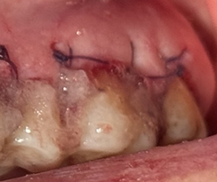
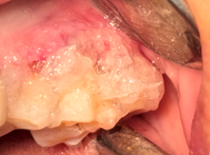
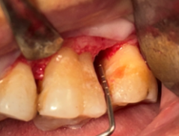

A
B
ب
C

Figure 1. Photographs of surgical procedures. A) Intrasulcular incision, reflection of a mucoperiosteal flap, removal of granulation tissue, thorough scaling and root planing (SRP), and irrigation B) Injection of the gel in an overfill manner C) Suturing using the sling technique

2.4 Study Parameters
2.4.1 Clinical Parameters
The following clinical parameters were assessed at baseline and at 6 months post-operatively by a calibrated independent examiner who was blinded to the treatment allocation:
- Probing Pocket Depth (PPD): The distance from the gingival margin to the deepest point of the gingival sulcus or periodontal pocket, measured with a
calibrated periodontal probe (e.g., UNC-15 or Williams probe) to the nearest millimeter.
- Clinical Attachment Level (CAL): The distance from a fixed reference point on the tooth (e.g., the cementoenamel junction, CEJ) to the base of the pocket. In cases where the CEJ was exposed due to gingival recession, the CAL was measured from the CEJ to the bottom of the pocket.
- Gingival Recession (GR): The distance from the CEJ to the gingival margin. Recession was measured only when the gingival margin was apical to the CEJ.
- Gingival Index (GI): Assessed using the criteria described by Löe and Silness (1963), scoring gingival inflammation on a scale of 0 to 3.
- Subtraction Radiography( RDD): Assessment of pre- and post-operative radiographic density differences
2.4.2 Radiographic Assessment
Baseline periapical radiographs (pre-operative) were obtained using a film holder (Rinn XCP, Kavo Kerr, China) and a size-2 digital PSP sensor (Soredex, Helsinki, Finland). To record the patient’s occlusion for positioning reproducibility, an impression material (Duralay, Reliance, Illinois, USA) was used at the bite block area of the film holder. The images were scanned using a phosphor plate scanner (Kavo, Biberach, Germany) and processed with Cliniview software version 10.2.6 (Soredex, Tuusula, Finland), then stored for future comparison.
At the 6-month follow-up, radiographs were repeated using the registered bite block, the same size-2 PSP sensor (Soredex, Helsinki, Finland), and identical exposure parameters. Digital subtraction of the baseline and post-treatment images was performed using Photoshop CS6 software (Adobe Systems, California, USA). Areas showing reduced radiographic density (radiolucency) were considered negative changes; areas showing increased density (radiopacity) were considered positive changes; and areas with no observable difference in density were classified as unchanged.
The blinded examiner performed all radiographic measurements.
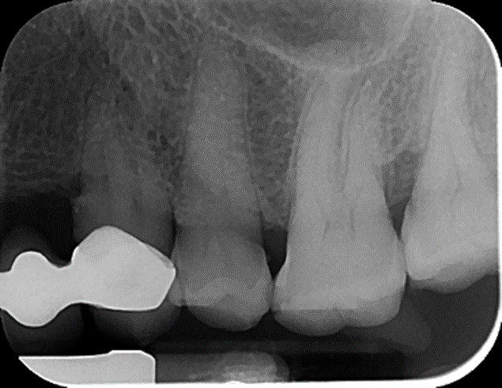
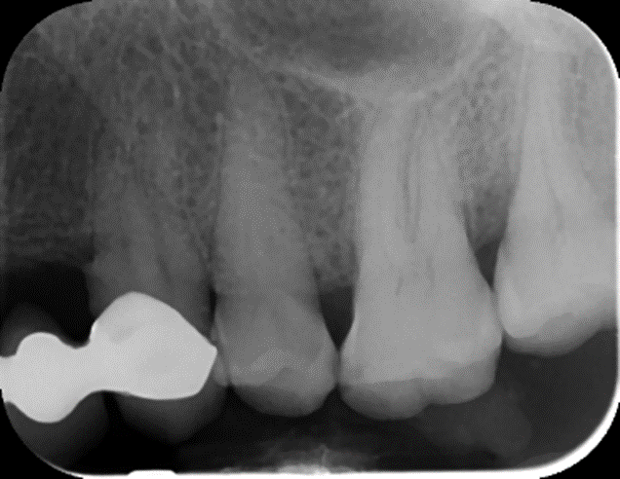
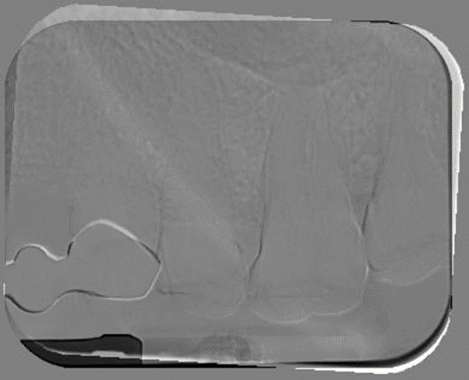
C
B
ب
A
B
ب
C

Figure 2. Radiographic evaluation before and after the procedure. A) Pre-operative, B) Post-operative, C) Subtraction radiography
2.5 Statistical Analysis
Statistical analysis was performed using SPSS software, version 26. Descriptive statistics were presented in the form of tables and charts. To compare quantitative variables within each group before surgery and 6 months after surgery, the Wilcoxon signed-rank test was used. The Mann-Whitney U test was employed to compare the magnitude of changes over the 6-month period between the two groups. Changes in qualitative variables over time and between the two groups were assessed using the McNemar test, Chi-square test, and Fisher’s exact test. A significance level of p < 0.05 was considered statistically significant.
3- Results
A total of 26 sites exhibiting proximal intrabony defects were surgically treated in the study population. The mean age of the participants was 23.46 years, with a standard deviation of 8.86 years. The gender distribution within the study cohort was equal, with an equal number of male and female participants.
3-1: Intra-group Comparisons
Chitosan-free gel group
Table 1 presents a comprehensive comparison of Pocket Probing Depth (PPD) and Clinical Attachment Level (CAL) measurements obtained before and six months following surgical intervention in the chitosan-free gel group. The results indicate that both PPD and CAL demonstrated statistically significant reductions after the surgical procedure. These findings were supported by the Wilcoxon signed-rank test, which yielded P-values less than 0.05 for both parameters, signifying a substantial improvement in periodontal health.

Table 1. Comparison of PPD and CAL in the chitosan-free gel group before and 6 months after surgery.
Index | Immediately before surgery  (Mean±SD) | 6 months  after surgery  (Mean±SD) | Mean change ±SD | P- value*
PPD(mm) | 5.08 ± 0.64 | 4.08±0.95 | 1.00±1.08 | 0.012
CAL(mm) | 5.00 ± 0.82 | 4.00 ± 1.35 | 1.00 ± 1.29 | 0.022

*Wilcoxon test

An evaluation of gingival recession within this group revealed no discernible change in the distribution of positive and negative cases when comparing pre-operative and post-operative measurements. The McNemar test, utilized for paired categorical data, returned a P-value of 1.000, indicating no statistically significant alteration in the incidence of gingival recession.
Table 2. Comparison of gingival recession in the chitosan-free gel group.
p-value = 1/00 |  | 6-month After Surgery |  | Total
 |  | Negative | Positive | Total
Immediately Before Surgery | Negative | 10 | 0 | 10
Immediately Before Surgery | Positive | 0 | 3 | 3
Total |  | 10 | 3 | 13
The Gingival Index (GI) exhibited a significant decrease in this group, transitioning from a mean pre-operative score of 1.69 ± 0.48 to a post-operative score of 0.92 ± 0.28. This reduction was statistically significant (P = 0.002), as determined by the Wilcoxon signed-rank test, suggesting an improvement in gingival health and a reduction in inflammation.

Table 3. Gingival index in the chitosan-free gel group before and 6 months after surgery.
GI | Mean ± SD | Min | Max | P-value*
Before Surgery | 1.69 ± 0.48 | 1.00 | 2.00 | 0.002
6-month After Surgery | 0.92 ± 0.28 | 0.00 | 1.00 | 0.002
*Wilcoxon test
Chitosan-containing gel group
Table 4 outlines the PPD and CAL values for the chitosan-containing gel group. Six months postoperatively, significant reductions were observed in both PPD and CAL. The mean reduction in PPD was 2.15 ± 0.69 mm, and the mean reduction in CAL was 2.31 ± 0.75 mm. Both of these changes were highly statistically significant, with P-values of 0.001 obtained from the Wilcoxon signed-rank test.
Table 4. Comparison of PPD and CAL in the chitosan-containing gel group.
Index | Immediately before surgery  (Mean±SD) | 6 months  after surgery  (Mean±SD) | Mean change ±SD | P- value*
PPD(mm) | 4.92 ± 0.69 | 2.77 ± 0.69 | 2.15 ± 0.69 | 0.001
CAL(mm) | 4.77 ± 0.75 | 2.46 ± 0.75 | 2.31 ± 0.75 | 0.001
*Wilcoxon test

Regarding gingival recession in this group, one patient experienced an improvement in their condition. However, an analysis using the McNemar test, which assesses changes in paired categorical data, indicated that this observed improvement was not statistically significant, with a P-value of 1.000
Table 5. Comparison of gingival recession in the chitosan-containing gel group.
p-value = 1/00 |  | 6-month After Surgery |  | Total
 |  | Negative | Positive | Total
Immediately Before Surgery | Negative | 9 | 0 | 9
Immediately Before Surgery | Positive | 1 | 3 | 4
Total |  | 10 | 3 | 13
The GI also demonstrated a significant decrease in the chitosan-containing gel group. The mean GI reduced from a pre-operative value of 1.69 ± 0.52 to a post-operative value of 0.92 ± 0.48. This reduction was statistically significant with a P-value of 0.001, as confirmed by the Wilcoxon signed-rank test, indicating enhanced gingival health in this treatment arm.
Table 6. Gingival index in the chitosan-containing gel group before and 6 months after surgery.
GI | Mean ± SD | Min | Max | P-value*
Before Surgery | 1.69 ± 0.52 | 1.00 | 2.00 | 0.001
6-month After Surgery | 0.92 ± 0.48 | 0.00 | 1.00 | 0.001
*Wilcoxon test
3-2: Between-group Comparisons
Table 7. Mean changes in indices between the two groups.
Variable | Chitosan-free gel group | Chitosan-containing gel group | P-value*
Variable | (mean ± SD) | (mean ± SD) | P-value*
PPD(mm) | 1.00 ± 1.08 | 2.15 ± 0.69 | 0.006
CAL(mm) | 1.00 ± 1.29 | 2.31 ± 0.75 | 0.009
GI (mm) | 0.77 ± 0.44 | 1.15 ± 0.55 | 0.153
*Mann–Whitney U test
A direct comparison of the outcomes between the two groups revealed statistically significant differences in the reduction of PPD and CAL. Specifically, the chitosan-containing gel group demonstrated a significantly greater reduction in both PPD (P = 0.006) and CAL (P = 0.009) compared to the chitosan-free gel group, as assessed by the Mann–Whitney U test. While the GI change was numerically higher in the chitosan-containing group (1.15 ± 0.55) compared to the chitosan-free group (0.77 ± 0.44), this difference did not reach statistical significance (P = 0.153), indicating that both treatments similarly improved gingival health.
Figure 1 illustrates the changes in gingival recession between the two treatment groups. The analysis, conducted using Fisher’s exact test, showed no new cases of gingival recession developing post-operatively in either group, and only one instance of recession improvement was noted in the chitosan-containing gel group. The overall P-value for this comparison was 1.000, indicating no statistically significant difference in gingival recession changes between the groups.
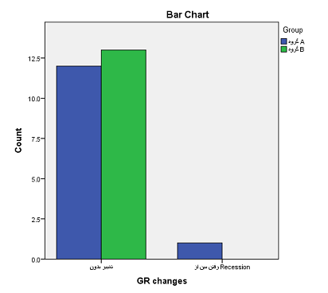
Figure 3: Comparison of changes in Gingival Recession status after 6 months of surgery between two groups
3-3: Radiographic Evaluation
Table 8. Radiographic subtraction results between groups at 6 months.
 | Non-Chitosan Gel Group | Chitosan Gel Group | P-value*
No change | 4 (30.8%) | 11 (84.6%) | <0.001
Negative change | 9 (69.2%) | 1 (7.1%) | <0.001
Positive change | 0 (0.0%) | 1 (7.7%) | <0.001
*Chi-square test
The radiographic evaluation, employing subtraction analysis to assess changes in bone levels between the two groups at the 6-month follow-up, yielded significant findings. The chitosan-containing gel group exhibited a markedly higher rate of bone fill (positive change) and a substantially lower rate of bone loss (negative change) compared to the chitosan-free gel group. Specifically, 84.6% of sites in the chitosan group showed no significant change, implying stability or improvement, whereas only 30.8% of sites in the chitosan-free group demonstrated no change, with a substantial 69.2% exhibiting bone loss (negative change). The chi-square test confirmed that these differences in radiographic outcomes were statistically significant (P = 0.005). This suggests that the chitosan-containing gel significantly promoted bone regeneration or at least preserved existing bone more effectively than the chitosan-free gel.

4-Discussion
The findings of this study demonstrated that in the chitosan gel group, significant improvements were observed in PPD, CAL, and GI six months after surgery. Moreover, positive cases of gingival recession decreased by one in this group after six months post-surgery. In addition, both PPD and CAL showed significantly greater reductions in the chitosan gel group compared with the non-chitosan gel group. Radiographical subtraction analysis indicated one case of bone formation in the chitosan gel group, with no changes in the remaining cases and no further bone loss compared to the control group. Given that previous studies have evaluated natural-origin chitosan gel as a carrier for drugs or as an osteogenic agent to stimulate the formation of new bone, soft tissue, and periodontal regeneration (17), tissue regeneration is only possible when viable cells are present around the lesion to respond to signaling molecules such as growth factors. Some reports have used chitosan combined with autografts or other grafting materials to transfer viable osteogenic cells to defect sites (8). In this study, since the surrounding viable tissues already contained growth factors needed to induce bone formation, no grafting material was used with chitosan. However, considering the defects were moderate to severe intrabony lesions, the amount of growth factors may have been insufficient to induce substantial bone regeneration, thus explaining the absence of a marked regenerative effect of chitosan. Its scaffold structure, however, might have prevented further bone loss .(20, 21)
In another 2024 study by Madieh on mandibular molar furcation involvement, significant reductions in VPD, VCAL, HPD, and GI, as well as decreased GR and evidence of bone formation in subtraction radiography, were reported for the chitosan gel group (22), aligning with our clinical findings though differing radiographically, possibly due to site-specific surgical differences. Sankari and Meenakshi (2021) showed that chitosan nanohydrogel significantly reduced CAL and PPD compared to controls (1), consistent with our data. Harikumar et al. (5) demonstrated enhanced PD reduction using GTR with collagen–chitosan film. In contrast, Faghani et al. (2021) found no significant CAL difference between chitosan particle and control groups (6), likely due to differences in delivery form—gel in our study versus high/low molecular weight particles in theirs.
Radiographical subtraction was used here in parallel to previous work (6, 19) to assess bone density changes at six months. Differences might, again, stem from volumetric changes in Chitosan form and positional discrepancies. Ardakani et al. (23) showed that chitosan application in post-extraction sockets significantly increased bone density compared to controls, possibly due to higher local levels of growth factors. Regarding GI, both groups showed reduced gingival inflammation, with greater improvement in the chitosan group, potentially due to chitosan’s anti-inflammatory properties as confirmed by Narvaez-Flores et al. (13). Its antibacterial activity has also been linked to bacterial cell surface binding and DNA binding mechanisms (14). A key strength of this study was the double-blind design, with both groups receiving gel differing only by chitosan content, minimizing bias. Clinically, chitosan gel shows promise as a periodontal therapeutic, particularly in hydrogel form, to reduce inflammation, facilitate tissue healing, and prevent bone loss.

Conclusion
Within the limitations of this study, chitosan-containing gel was effective in improving periodontal parameters (pocket depth, clinical attachment level, and gingival health index) and preventing bone loss in treated sites. These findings suggest that chitosan hydrogel can serve as a useful adjunctive agent in periodontal defect management. Further long-term studies are recommended to confirm these effects and explore potential enhancements in bone regeneration capacity.

Author Contributions
Marie Talebi – Performed all surgical procedures on the patients, injection of gel into the area (according to the intervention protocol), Dr. Sina Haqani Far – Implemented the complete radiographic imaging protocol ,.Dr. Sohrab Kazemi – Designed and prepared the chitosan gel used in the study.Seyed Ali Seyed Majidi – Performed statistical analysis of the data Niloofar Jenabian – Served as principal supervisor and corresponding author,
References
1. Meenakshi SS, Sankari M. Effectiveness of chitosan nanohydrogel as a bone regenerative material in intrabony defects in patients with chronic periodontitis: a randomized clinical trial. Journal of advanced oral research. 2021;12(2):222-8.
2. Kwon T, Lamster IB, Levin L. Current concepts in the management of periodontitis. International dental journal. 2021;71(6):462-76.
3. Carranza FA, Newman MG, Takei HH, Klokkevold PR. Newman and carranza's clinical periodontology. (No Title). 2019.
4. Goldman HM, Cohen DW. The infrabony pocket: classification and treatment. The Journal of Periodontology. 1958;29(4):272-91.
5. Harikumar K, Nandakumar K, Devadas C, Mathew S. Collagen-chitosan barrier membrane, a novel indigenous and economic material for management of periodontal infrabony defects-a case-control studyl. 2015.
6. Faghani M, Jenabian N, Haghanifar S, Khafri S. Clinical and Radiographic Evaluation of Chitosan Particles in Treatment of Intrabony Periodontal Defects: A Clinical Trial. Frontiers in Dentistry. 2021;18:23.
7. Thrombelli L. Which reconstructive procedures are effective for treating the periodontal intraosseous defects. Periodontol 2000. 2005;37:88-105.
8. Zhang K, Zhao M, Cai L, Wang Z-k, Sun Y-f, Hu Q-l. Preparation of chitosan/hydroxyapatite guided membrane used for periodontal tissue regeneration. Chinese Journal of Polymer Science. 2010;28(4):555-61.
9. Giannoudis PV, Dinopoulos H, Tsiridis E. Bone substitutes: an update. Injury. 2005;36(3):S20-S7.
10. Norowski Jr PA, Bumgardner JD. Biomaterial and antibiotic strategies for peri‐implantitis: A review. Journal of Biomedical Materials Research Part B: Applied Biomaterials: An Official Journal of The Society for Biomaterials, The Japanese Society for Biomaterials, and The Australian Society for Biomaterials and the Korean Society for Biomaterials. 2009;88(2):530-43.
11. Ji QX, Lü R, Zhang WQ, Deng J, Chen XG. In vitro evaluation of the biomedical properties of chitosan and quaternized chitosan for dental applications. Carbohydrate research. 2009;344(11):1297-302.
12. Aranaz I, Mengíbar M, Harris R, Paños I, Miralles B, Acosta N, et al. Functional characterization of chitin and chitosan. Current chemical biology. 2009;3(2):203-30.
13. Narvaez-Flores JJ, Vilar-Pineda G, Acosta-Torres LS, Garcia-Contreras R. Cytotoxic and anti-inflammatory effects of chitosan and hemostatic gelatin in oral cell culture. Acta Odontoloógica Latinoamericana. 2021;34(2):98.
14. Mhaske SP, Ambiti R, Jagga U, Paul U, Shanmukappa SM, Iska D. Clinicomicrobiological Evaluation of 2% Chitosan Mouthwashes on Dental Plaque. J Contemp Dent Pract. 2018;19(1):94-7.
15. Islam S, Bhuiyan MR, Islam M. Chitin and chitosan: structure, properties and applications in biomedical engineering. Journal of Polymers and the Environment. 2017;25(3):854-66.
16. De Carvalho M, Stamford TCM, Dos Santos E, Tenorio P, Sampaio F. Chitosan as an oral antimicrobial agent. Formatex. 2011;2012(1):13.
17. Okamoto Y, Yano R, Miyatake K, Tomohiro I, Shigemasa Y, Minami S. Effects of chitin and chitosan on blood coagulation. Carbohydrate Polymers. 2003;53(3):337-42.
18. Tanikonda R, Ravi RK, Kantheti S, Divella S. Chitosan: Applications in Dentistry. Trends in Biomaterials & Artificial Organs. 2014;28(2).
19. Boynueğri D, Özcan G, Şenel S, Uç D, Uraz A, Öğüş E, et al. Clinical and radiographic evaluations of chitosan gel in periodontal intraosseous defects: a pilot study. Journal of biomedical materials research Part B: Applied Biomaterials. 2009;90(1):461-6.
20. Rabea EI, Badawy ME-T, Stevens CV, Smagghe G, Steurbaut W. Chitosan as antimicrobial agent: applications and mode of action. Biomacromolecules. 2003;4(6):1457-65.
21. Thangavelu A, Stelin KS, Vannala V, Mahabob N, Hayyan FMB, Sundaram R. An overview of chitosan and its role in periodontics. Journal of Pharmacy and Bioallied Sciences. 2021;13(Suppl 1):S15-S8.
22. <Parastoo Madieh, Sina Haghanifar, Sohrab Kazemi, Seyedali Seyedmajidi, Niloofar Janabian. Clinical and Radiographic Outcomes of Chitosan Gel in the Management of Grade II Furcation Defects A Clinical Trial. Published online 202.pdf>.
23. Ezoddini-Ardakani F, Azam AN, Yassaei S, Fatehi F, Rouhi G. Effects of chitosan on dental bone repair. Health. 2011;3(4):200-5.

